Podcast Pulse Test · Enrollment Impact Analysis · March – April 2026

What We Tested
We ran a podcast spend pulsing test across three periods to see whether increasing or decreasing podcast spend meaningfully changes overall enrollments. A statistical model (trained on historical enrollment trends through March 23) was used to project what enrollments would have looked like without any spend change — the counterfactual baseline.
BAU (3/16 – 3/31) | 50% BAU – Spend Down (4/01 – 4/21) | 150% BAU – Spend Up (4/22 – 4/30)
$228,944 · ~$91.6K/wk  (baseline spend) | $330,000 total · $110K/wk  (reduced spend) | $220,000 total · $220K/wk  (increased spend)

Actual Enrollments vs. Expected Baseline
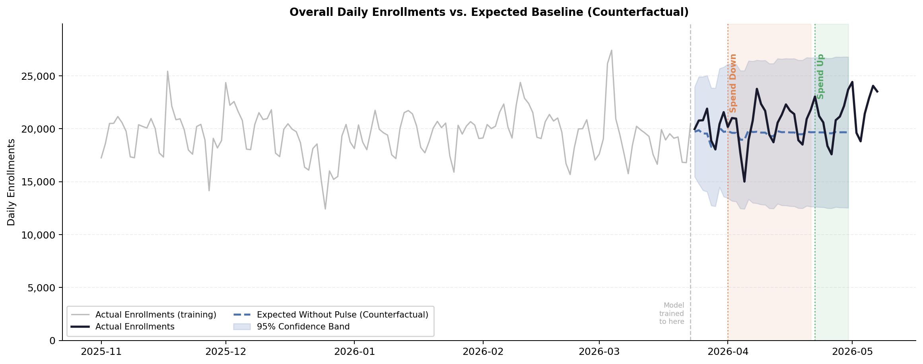

Results by Period
Period | Spend Level | Actual  Enrollments | Expected  (Counterfactual) | Lift / Drop  (#) | Lift / Drop  (%) | Stat Sig?
50% BAU – Spend Down | $330,000 total  ($110K/wk) | 428,054 | 410,915 | +17,139 | +4.2% | No — not significant
150% BAU – Spend Up | $220,000 total  ($220K/wk) | 188,652 | 176,832 | +11,820 | +6.7% | No — not significant

Key Takeaways
1 | No evident lift or drop in enrollments during the pulse periods. Neither reducing podcast spend to 50% of BAU nor increasing it to 150% produced a clear, measurable change in overall daily enrollments. Actuals in both windows stayed within the range the model would have expected regardless of the spend change.

2 | The scale of podcast spend may not be large enough to move the needle on total enrollments. Podcast is one channel within a broader marketing mix. At the spend levels tested ($110K/wk down and $220K/wk up), the channel's contribution may simply be too small relative to total enrollment volume to produce a detectable shift — especially over a short window.

3 | Other factors are likely the dominant drivers of April enrollment trends. Broad seasonality, other marketing channels, and organic product trends all influence enrollment at a scale that can mask the effect of a single channel pulse. The April enrollment pattern appears to reflect these broader forces rather than podcast spend specifically.

4 | Recommendation: further testing with a cleaner isolation design. To more reliably measure podcast's incremental impact, consider a geo holdout test (pause podcasts in specific markets while maintaining them in others) or a longer pulse window at a larger spend swing — giving the signal more room to emerge above the noise.

Methodology: SARIMA(1,1,1)(1,0,0,7) time-series model trained on May 2025 – Mar 23, 2026. Counterfactual = model projection of expected enrollments absent any spend change. Validated on BAU hold-out week (Mar 24–31) with 4.6% MAPE. Significance tested at 95% confidence level.

